From Raster to Terra & Stars

# Current developments in raster processing in R

Konstantin Schellenberg, 28.01.2020

GEO 404, Wintersemester 2020

Supervisor: Patrick Schratz M.Sc.

Geographic raster data models consist of a raster header and a matrix (with rows and columns) representing equally spaced cells (pixels). (Lovelace et al. 2019)

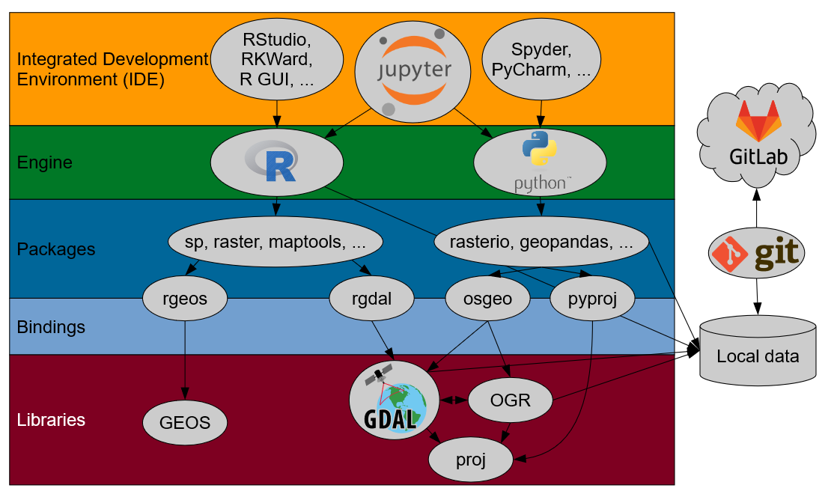

Figure 1 The world of spatial processing in R and Python

1. Raster

* read and write raster data in most formats -> GDAL (C++)
* perform raster operations -> GEOS (C++)
* visualise data

Benefits:

* Raster*-functions break down tasks to lightweight chunks to be processed sequentially.
* feases most raster operations possible in desktop GIS systems (and more...)
* capacity to run in parallel
* exellent manual, support and large user community

Shortcomings:

Supposing we want our data in a scalable structure...

* no real data cubes: either different bands _or_ time steps

Alternatives:

* + - 1. gdal cubes
      2. stars
      3. open data cube
* low processing speed

1. Stars
   * heterogeneous data (numeric, logical and Date) as multi-dimensional arrays
   * clear and strong spatial and temporal indeces
   * large on-disc data and remote server solutions

… by using `sf` methods and following the tidy tools manifesto. [@tidyverse2019]

* + Handles spatio-temporal data as
    1. raster hypercubes (2 and more dimension)
    2. vector hypercubes

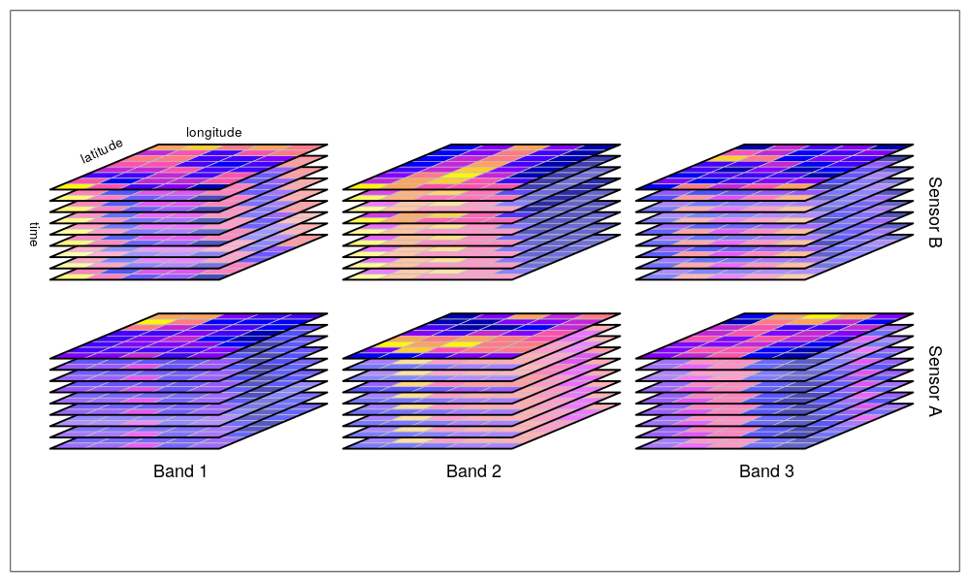

Figure 2 Hypercubes

1. Terra

**Aims to replace the `raster` package (in the future)**

* + implements new S4 classes (SpatRaster and SpatVector)
  + referring to C++ objects, much faster than `raster`
  + virtual raster and vector operations

Functions (similar to raster):

* creating, manipulating, and writing raster data
* raster algebra
* higher-level raster operations
* integration with spatial modeling methods

Virtual file handling (similar to `stars_proxy`-objects)

* saving metadata to objects, keeping data on disc
* processing in chunks
* no filename: temporarily stored to temporary file
* new, cleaner version of raster
* CRAN release still to come